Martinez Historical Society Home Tour 2107

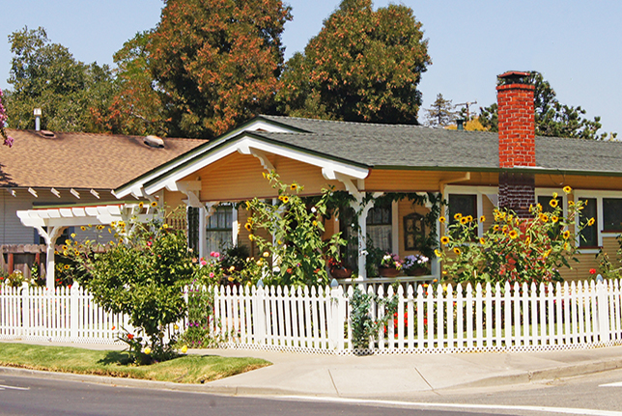
This 1925 Craftsman home on Alhambra Avenue has a beautiful interior with most of its original features intact. It is locally famous for its garden which is abloom all year long.

With fall approaching, preparation for the 11th Annual Martinez Historical Society Home Tour is in progress. The Tour takes place on Saturday, October 14 from 10:00 am to 4:00 pm. The starting point will be the Shell Clubhouse at 1635 Pacheco Boulevard. Bus transportation will be provided, but you will also have the option of driving your own cars.

On the Tour this year are 6 or 7 privately owned residences and gardens in the historic district of Martinez known as Portuguese Flats. Once you arrive in this district, you will have the option of walking from house to house. The homes are of the type that young couples are purchasing, renovating and upgrading. These homes fit the theme of the Tour which is “Fun, Funky and Small.”

Also on the Tour is the historic Mormon Chapel built in 1939/1940 by the Latter Day Saints. This building is now home to the Martinez Early Childhood Center. Another added attraction is a Zen Garden (Japanese Rock Garden) that a creative homeowner placed on the flat roof of her garage to improve the view from her hillside house. There will also be a retro Silver Stream travel trailer on the Tour which will be open for viewing.

There will be musicians stationed at many of the houses. Antique automobiles will also be parked in front of the homes on the Tour. Booths set up by various organizations will dot the route also.

To learn more about the Historic Home Tour, please visit the website at www.MartinezHomeTour.com

Tickets can be purchased online $25 by credit card. Tickets are also available from the following merchants (cash or check):

- Char’s Flower Shoppe, 635 Main Street
- I’ve Been Framed, 411 Ferry Street
- Peirano Jewelers (Nob Hill Supermarket Shopping Center)
- The UPS Store (Lucky Supermarket Shopping Center)

Day-of-the-event tickets are $30. Discounted tickets are available at the Farmers Market each Sunday on Main Street for $20 at the Martinez Historical Society booth.

The sponsors of the Tour enable the Historical Society to keep the ticket prices low. Please support our sponsors when you can:

- Shell Martinez Refinery
- Cole Real Estate
- Community Focus
- Republic Services
- Shell Martinez Chemical Co.
- Shell Western States Credit Union
- Hagin’s Automotive
- Bisio & Dunivan
- Les Schwab Tire of Martinez
- Ecomulch
- Web4Homes, Kevin Murray, Realtor
- Schroder Insurance Services
- Edward Jones, John Fuller, Financial Advisor
- IBEW Local No. 32
- City of Martinez

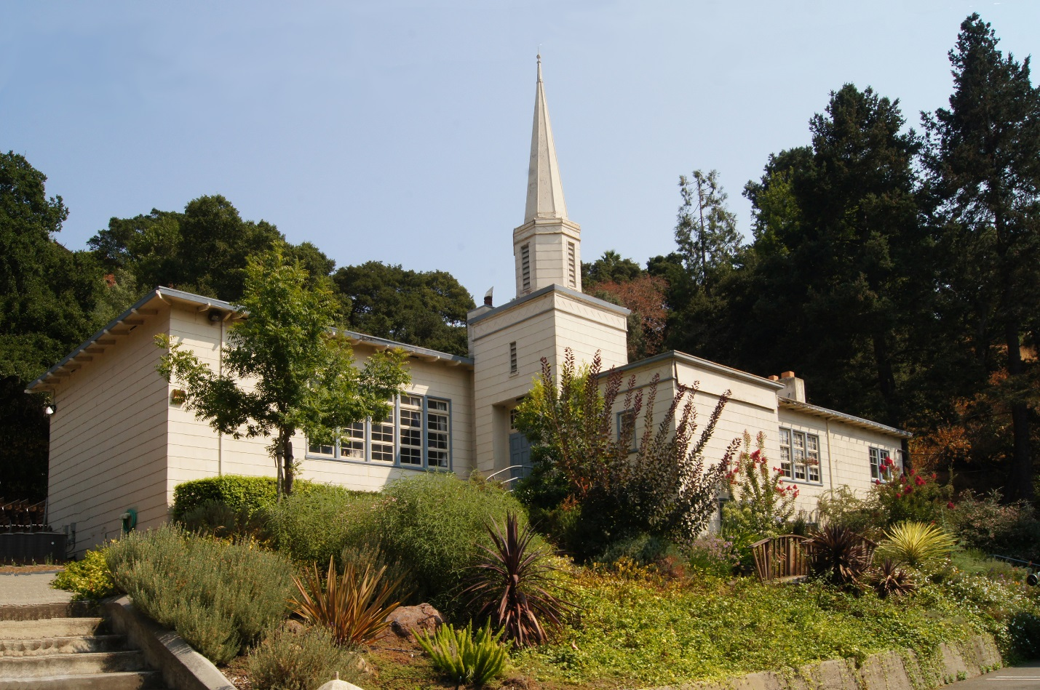
Today this is the Martinez Early Childhood Center. But it was originally the first LDS Chapel in Martinez. It was constructed by the Mormon community in 1939 / 1940.

